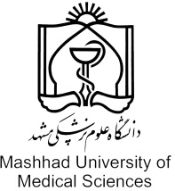 | program Information
NO.
Program Type |  | Degree Based …………….....  Nondegree-Based ……..…. |   
Level of Study |  | Undergraduate ………..……  Master …………………..……...  PhD ………………………..…….  Post Doc …………………..…..  Speciality ………………..…….  Subspeciality …………………  Fellowship ……………..……..  Short term Course ………… |             
School |  | School of Dentistry
Department |  | Orthodontics
Major/ Name of Program |  | Application of Temporary Anchorage Devices in Clinical Orthodontics
Keyword(3 Words) |  | Temporary Anchorage Devices, Orthodontics, Orthognathic surgery
Language Requirment |  | English
Admission Requirment |  | DDS, MSc or PHD in Orthodontics
Contact Information |  | Phone :+985138832300
 |  | Fax :+985138829500
 |  | Mobile ::+989151117079
 |  | Email : heravif@mums.ac.ir
 |  | Address : Department of Orthodontics, School of Dentistry, Park Square, Mashhad University of Medical Sciences, Mashhad, Iran
 |  | Contact Person Name : Dr farzin heravi
Description (500 words) |  | Interdisciplinary procedures between the departments of orthodontics and orthognathic surgery. Primary activities include using temporary anchorage devices for special tooth movements, follow-up of orthognathic surgery cases, surgery-like orthodontics by application of mini-plates, and observation of orthognathic surgeries.
Program Detail

